|  |  |  |  |
| --- | --- | --- | --- |
| **Type of Sampling** | **When to use it** | **Advantages** | **Disadvantages** |
| **Probability Strategies** |  |  |  |
| **Simple Random Sampling** | When the population members are similar to one another on important variables | Ensures a high degree of representativeness | Time consuming and tedious |
| **Systematic Sampling** | When the population members are similar to one another on important variables | Ensures a high degree of representativeness, and no need to use a table of random numbers | Less random than simple random sampling |
| **Stratified Random Sampling** | When the population is heterogeneous and contains several different groups, some of which are related to the topic of the study | Ensures a high degree of representativeness of all the strata or layers in the population | Time consuming and tedious |
| **Cluster Sampling** | When the population consists of units rather than individuals | Easy and convenient | Possibly, members of units are different from one another, decreasing the techniques effectiveness |
| **Non-Probability Sampling** |  |  |  |
| **Convenience Sampling** | When the members of the population are convenient to sample | Convenience and inexpensive | Degree of generalizability is questionable |
| **Quota Sampling** | When strata are present and stratified sampling is not possible | Insures some degree of representativeness of all the strata in the population | Degree of generalizability is questionable |

* Sampling is the process of selecting a representative group from the population under study.
* The target population is the total group of individuals from which the sample might be drawn.
* A sampleis the group of people who take part in the investigation. The people who take part are referred to as “participants”.
* Generalisability refers to the extent to which we can apply the findings of our research to the target population we are interested in.

## The Purpose of Sampling

In psychological research we are interested in learning about large groups of people who all have something in common. We call the group that we are interested in studying our 'target population'.

In some types of research the target population might be as broad as all humans, but in other types of research the target population might be a smaller group such as teenagers, pre-school children or people who misuse drugs.

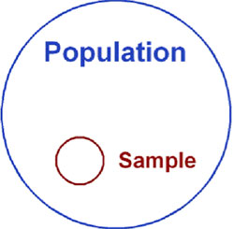

It is more or less impossible to study every single person in a target population so psychologists select a sample or sub-group of the population that is likely to be representative of the target population we are interested in.

If the sample we select is going to represent the target population then we need to make sure that the people in it are similar to the other members of the target population. This is important because we want to generalize from the sample to target population.

The participants in research, the sample, should be as representative as possible of the target population. The more representative the sample, the more confident the researcher can be that the results can be generalized to the target population.

One of the problems that can occur when selecting a sample from a target population is sampling bias. Sampling bias refers to situations where the sample does not reflect the characteristics of the target population.

Many psychology studies have a biased sample because they have used an opportunity sample that comprises university students as their participants (e.g. [Asch](http://www.simplypsychology.org/asch-conformity.html)).

OK, so you’ve thought up this brilliant psychological study and designed it perfectly. But who are you going to try it out on and how will you select your participants? There are various sampling methods. The one chosen will depend on a number of factors (such as time, money etc.).

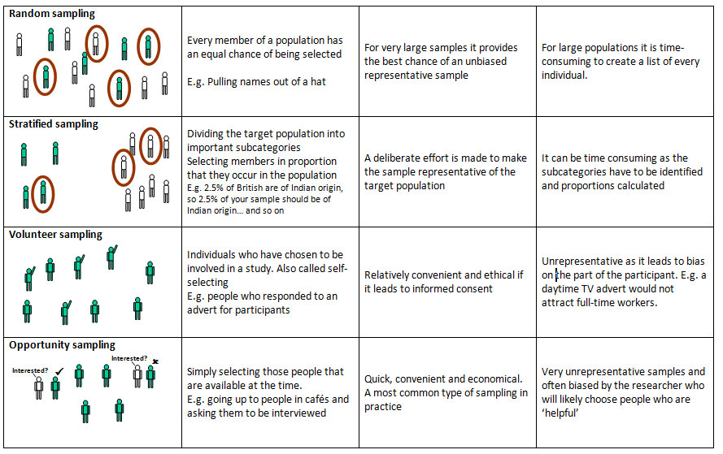

## 1. Random Sampling

Everyone in the entire target population has an **equal chance** of being selected.

This is similar to the national lottery. If the “population” is everyone who has bought a lottery ticket, then each person has an equal chance of winning the lottery (assuming they all have one ticket each).

Random samples require a way of naming or numbering the target population and then using some type of raffle method to choose those to make up the sample. Random samples are the best method of selecting your sample from the population of interest.

The **advantages** are that your sample should represent the target population and eliminate sampling bias, but the **disadvantage** is that it is very difficult to achieve (i.e. time, effort and money).

## 2. Stratified Sampling

The researcher identifies the different types of people that make up the target population and works out the **proportions** needed for the sample to be representative.

A list is made of each variable (e.g. IQ, sex etc.) which might have an effect on the research. For example, if we are interested in the money spent on books by undergraduates, then the main subject studied may be an important variable.

For example, students studying English Literature may spend more money on books than engineering students so if we use a very large percentage of English students or engineering students then our results will not be accurate.

We have to work out the relative percentage of each group at a university e.g. Engineering 10%, Social Sciences 15%, English 20%, Sciences 25%, Languages 10%, Law 5%, Medicine 15% The sample must then contain all these groups in the same proportion as in the target population (university students).

Gathering such a sample would be extremely time consuming and difficult to do (**disadvantage**). This method is rarely used in Psychology. However, the **advantage** is that the sample should be highly representative of the target population and therefore we can generalize from the results obtained.

## 3. Opportunity Sampling

Uses people from target population available at the time and willing to take part. It is based on **convenience**.

An opportunity sample is obtained by asking members of the population of interest if they would take part in your research. An example would be selecting a sample of students from those coming out of the library.

This is a quick way and easy of choosing participants (**advantage**), but may not provide a representative sample, and could be biased (**disadvantage**).

## 4. Systematic Sampling

Chooses subjects in a systematic (i.e. **orderly / logical**) way from the target population, like every nth participant on a list of names.

To take a systematic sample, you list all the members of the population, and then decided upon a sample you would like. By dividing the number of people in the population by the number of people you want in your sample, you get a number we will call n.

If you take every nth name, you will get a systematic sample of the correct size. If, for example, you wanted to sample 150 children from a school of 1,500, you would take every 10th name.

The **advantage** to this method is that is should provide a representative sample, but the **disadvantage** is that it is very difficult to achieve (i.e. time, effort and money).

## How many participants should be used?

This depends on several factors; the size of the target population is important. If the target population is very large (e.g. all 4-6 yr olds in Britain) then you need a fairly large sample in order to be representative.

If the target population is much smaller, then the sample can be smaller but still be representative. There must be enough participants to make the sample representative of the target population. Lastly, the sample must not be so large that the study takes too long or is too expensive!

## What is a non-probability sampling?

Non-probability sampling derives its control from the judgement of the investigator. In non-probability sampling, the cases are selected on bases of availability and interviewer judgement. Non-probability sampling has its strength in the area of convenience.

## Methods of non-probability sampling

The important non-probability sampling methods include

1. convenience sampling
2. quota control sampling; and
3. judgment sampling.

## Convenience sampling:

Convenience sampling is generally known as careless, unsystematic, accidental or opportunistic sampling. The sample is selected according to the convenience of the sample. The researcher selects certain units convenient to him. It requires no pre-planning for the selection of items. Convenience sampling ensures convenience in respect of availability of source list and accessibility of the units. Despite being unscientific, a large number of samples are convenient sampling.

### A convenience sampling is used in the following situations:

* when the universe is not clearly defined
* where sampling unit is not clear and
* when a complete source list is not available.

## Quota sampling:

Quota sampling combines the features of purposive sampling and stratified sampling. Under quota sampling, the field workers include only those units which conform to certain specified parameters in the sample. Each field worker is assigned quotas of number of units to include according to one or more characteristics. In order to increase the representativeness of a quota sample, the field worker may be instructed to contact every fourth house and interview one person till the quota is fulfilled.

### Advantages of Quota sampling

1. Quota sampling ensures convenience in executing sampling study.
2. When the respondent refuses to cooperate, he may be replaced by another person who is ready to furnish information.
3. Quota sampling is less expensive and speedy
4. When the population has no suitable frame, quota sampling is the only practical method.
5. Collection of data through Quota sampling method is not a time consuming one.

### Disadvantages of Quota sampling

1. The interviewer interviews people who are easily available and accessible. So, the possibility of collecting valuable data is affected in Quota sampling.
2. Bias arises in the matter of selection of sample units.
3. The work of the interviewer cannot be supervised properly. So, there is no certainty of correctness of data.
4. Quota sampling method requires several investigators. Each one cannot be equally competent. So, the results derived from the study may not be uniform.

## Judgement Sampling

Judgement sampling is one of the non-probability methods of sampling. Judgement sampling involves the selection of a group from the population on the basis of available information. It is the selection of the group by intuition on the basis of criteria deemed to be self evident. Under this method, units are included in the sample on the basis of the judgement that the units possess the required characteristics to qualify as representatives of the population.

### Advantages of Judgement sampling

The chief advantages of the judgement sampling are as follows:

1. Judgement sampling eliminates 5e cost and time in preparing the sample
2. Judgement sampling method enables the researcher to include the positive aspects of stratification in the sample.

### Disadvantages of judgement sampling

1. There is uncontrolled variability and bias in the estimates in Judgement sampling.
2. The success of Judgement sampling method is solely dependent on a thorough knowledge of the population and elimination of the use of inferential parametric statistical tools for the purpose of generalization.
3. Complete reliance on intuition and hunch is risky in Judgement sampling.

ANOTHER



Add a note...

Clipped from: https://explorable.com/non-probability-sampling

Non-probability sampling is a sampling technique where the samples are gathered in a process that does not give all the individuals in the population equal chances of being selected.

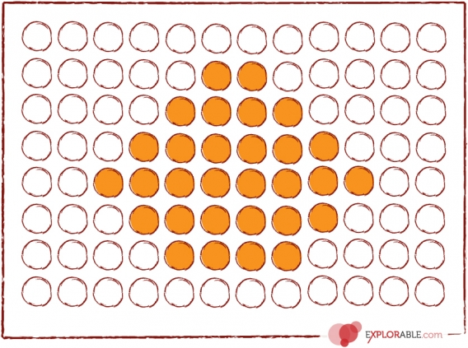

Non-Probability Sampling

In any form of research, true [random sampling](https://explorable.com/simple-random-sampling) is always difficult to achieve.

Most researchers are bounded by time, money and workforce and because of these limitations, it is almost impossible to randomly sample the entire population and it is often necessary to employ another sampling technique, the [non-probability sampling technique](http://www.socialresearchmethods.net/kb/sampnon.php).

In contrast with probability sampling, non-probability sample is not a product of a randomized selection processes. Subjects in a non-probability sample are usually selected on the basis of their accessibility or by the purposive personal judgment of the researcher.

The downside of the non-probablity sampling method is that an unknown proportion of the entire population was not sampled. This entails that the sample may or may not represent the entire population accurately. Therefore, the results of the research cannot be used in [generalizations](https://explorable.com/what-is-generalization)pertaining to the entire population.

## Types of Non-Probability Sampling

### Convenience Sampling

[Convenience sampling](https://explorable.com/convenience-sampling) is probably the most common of all sampling techniques. With convenience sampling, the samples are selected because they are accessible to the researcher. Subjects are chosen simply because they are easy to recruit. This technique is considered easiest, cheapest and least time consuming.

### Consecutive Sampling

[Consecutive sampling](https://explorable.com/sequential-sampling) is very similar to convenience sampling except that it seeks to include ALL accessible subjects as part of the sample. This non-probability sampling technique can be considered as the best of all non-probability samples because it includes all subjects that are available that makes the sample a better representation of the entire population.

### Quota Sampling

[Quota sampling](https://explorable.com/quota-sampling) is a non-probability sampling technique wherein the researcher ensures equal or proportionate representation of subjects depending on which trait is considered as basis of the quota.

For example, if basis of the quota is college year level and the researcher needs equal representation, with a sample size of 100, he must select 25 1st year students, another 25 2nd year students, 25 3rd year and 25 4th year students. The bases of the quota are usually age, gender, education, race, religion and socioeconomic status.

### Judgmental Sampling

[Judgmental sampling](https://explorable.com/judgmental-sampling) is more commonly known as purposive sampling. In this type of sampling, subjects are chosen to be part of the sample with a specific purpose in mind. With judgmental sampling, the researcher believes that some subjects are more fit for the research compared to other individuals. This is the reason why they are purposively chosen as subjects.

### Snowball Sampling

[Snowball sampling](https://explorable.com/snowball-sampling) is usually done when there is a very small population size. In this type of sampling, the researcher asks the initial subject to identify another potential subject who also meets the criteria of the research. The downside of using a snowball sample is that it is hardly representative of the population.

## When to Use Non-Probability Sampling

* This type of sampling can be used when demonstrating that a particular trait exists in the population.
* It can also be used when the researcher aims to do a [qualitative](https://explorable.com/qualitative-research-design), [pilot](https://explorable.com/pilot-study)or exploratory study.
* It can be used when randomization is impossible like when the population is almost limitless.
* It can be used when the research does not aim to generate results that will be used to create [generalizations](https://explorable.com/what-is-generalization) pertaining to the entire population.
* It is also useful when the researcher has limited budget, time and workforce.
* This technique can also be used in an initial study which will be carried out again using a randomized, probability sampling.
* In the research process, once the researcher decides who to study, he then needs to select a sample from the target population. To do this, the researcher selects from two basic sampling methods: probability and non-probability. In **probability sampling**, each element of the population has a known chance of being selected. A common probability sampling method is random sampling, where each element has an equal chance of being selected. In**non-probability sampling**, the selection of elements is based in some part on the judgment of the researchers. The selection relies on the personal judgment of the researcher rather than on chance to select the sample elements. Common types of non-probability sampling are convenience, judgment, and quota sampling.

## What Is Quota Sampling?

* **Quota sampling** is a type of non-probability sampling that involves a two-step process:
* **Step 1: Specify a list of relevant control categories or quotas such as age, gender, income, or education.** A **quota** is some specific requirement or predefined category. The target population is first segmented into mutually exclusive sub-groups, which means that one individual can be a member of only one category or sub-group. The researcher takes special care to obtain a sample that is similar to the target population on some specified control category.
* **Step 2: Collect a sample that has the same properties as the target population.** To do this, the researcher must know the distribution of these properties across that population. For example, let's look at a target population of college students at a local college. Because the researcher can access this data, he knows that in this given population, 43% of the students are male and 57% are female. For a sample size of 1,000, the researcher knows that 430 males and 570 females will need to be interviewed from that population.

## Quota Sampling Method

* To more realistically represent a given population, it would be necessary to control more than one category. For example, the researcher could select gender and age, or gender and income, or level of education and income, depending on the purpose of the study. Using our example, the researcher could add age (less than 21 years and 21 years and over) as a control category, specifying that half of the sample for each gender be from each age category. Now we are searching for 215 males under 21 years and 215 males 21 years and over, along with 285 females under 21 years and 285 females 21 years and over. What has happened here is that with every added category it may take longer to locate these individuals, thus adding cost and time to the process. However, the target population could be better represented if additional categories are considered.
* Why use multiple quotas? The intent of specifying multiple control categories or quotas is to improve the representation of particular groups within the population and ensure that groups are not over-represented. In our example, males and females would be interviewed until each category has reached its quota. Once 215 males under 21 years of age have been interviewed, no further male responses from that age category will be considered. Individuals for the remaining categories will continue to be interviewed until each quota is satisfied. This ensures that no more than 215 males and 285 females from each age category will be represented. In this way, no one category is over-represented according to the target population.

## Advantages and Disadvantages

* Let's consider some distinct advantages of quota sampling.

Advantages  of Quota Sampling

1. It is a useful technique to use in the preliminary stages of research.
2. It is easily administered.
3. It allows the researcher to easily compare groups.
4. It is useful when detailed accuracy is not important.
5. It can be used to obtain representative samples at a relatively low cost.
6. It may sometimes be the only approach that can be used.
7. Under certain conditions, it can obtain results close to those for conventional probability sampling. It is widely used by market researchers and political pollsters.